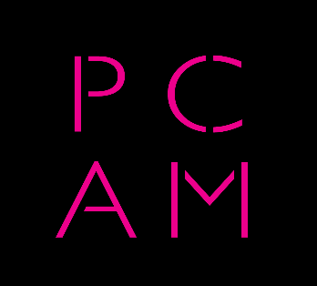

**Dear PCAM Member,**

As 2019 draws to a close I'd like to wish you all a very Happy Christmas.

Thank you for your continued support of PCAM and the work we are doing to uphold the conditions, standards and value of our industry. Whilst many of us have had our heads down working hard in a rapidly evolving marketplace, it's important to remember that your membership gives us the means to fight unfair conditions such as those that have recently come to light from major international broadcasters. Your membership also means that you have access to a wealth of knowledge and free education with our regular events at PRS For Music.

The recent event saw four of the UK's leading music supervisors give insight into their careers to a packed room of composers and producers. We had the opportunity to hear about their most impressive work along with some of the highs and lows they have experienced along the way.

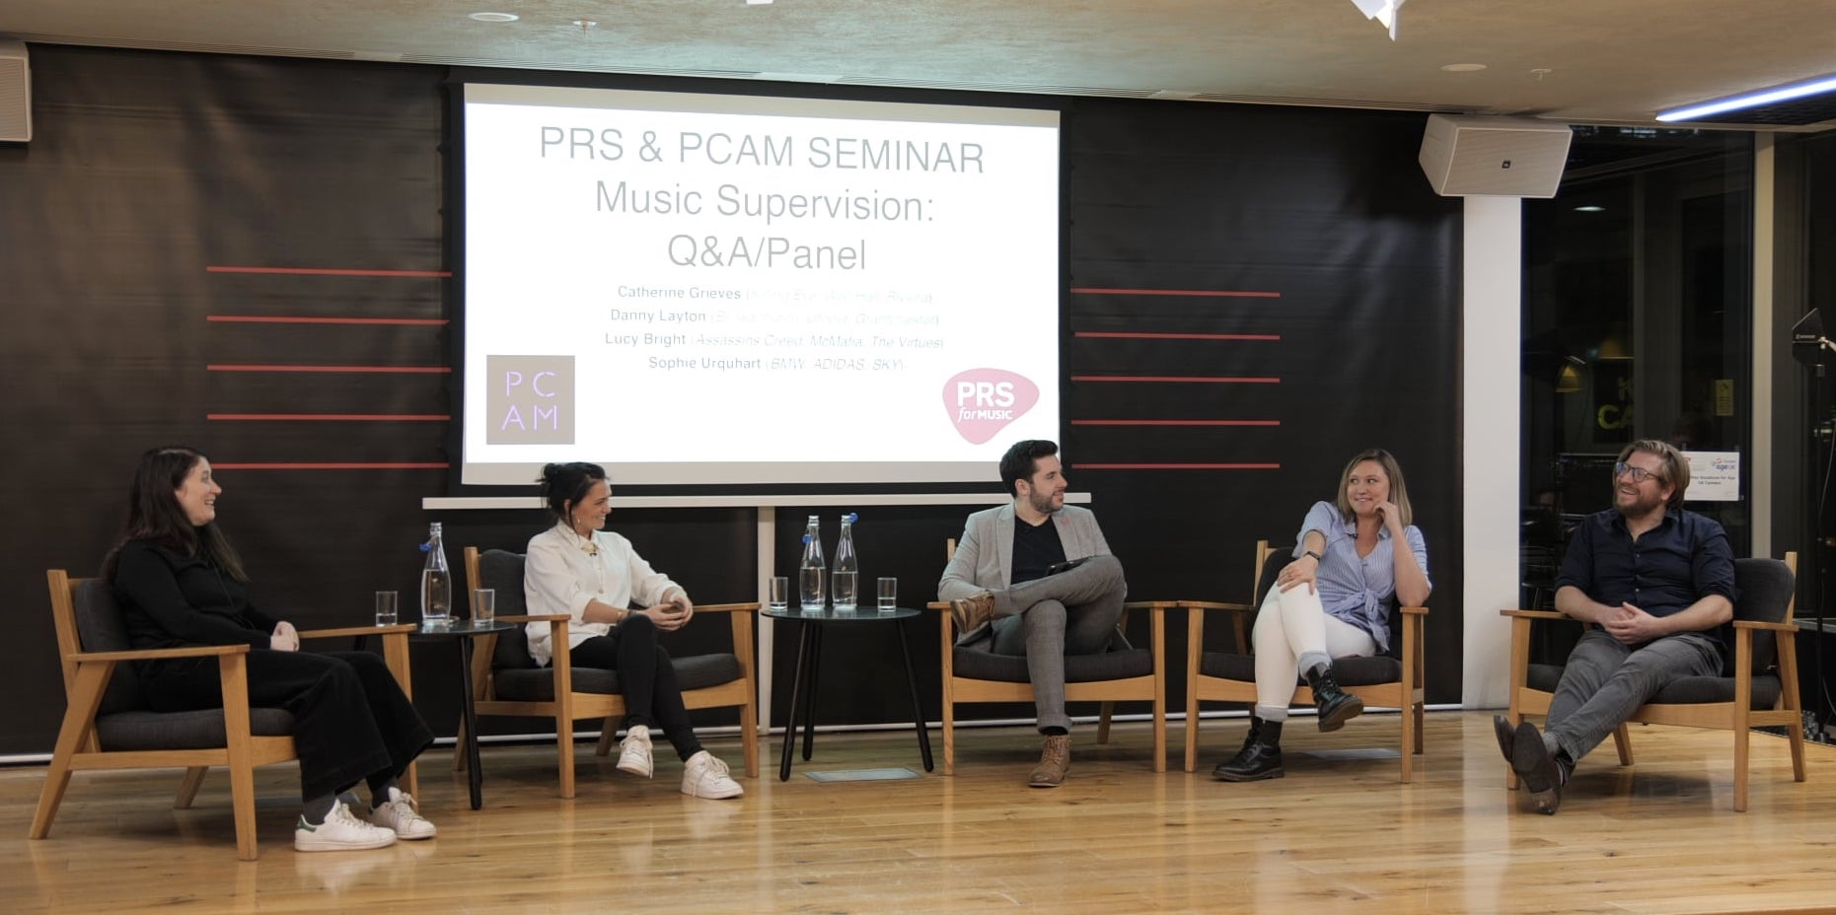

There were many tips and valuable takeaways for composers who are looking to get their work in front of music supervisors. These included:

* Supervisors are generally on the lookout for a strong, authentic voice, not a generalist.
* Be true to yourself. Promote your strength and be clear about how you communicate it.
* Make it easy for a supervisor to listen to your music. Give them a quick stream option and also a download should they want to save your music for future reference. No passwords. No rough, unfinished work.
* Make sure you properly name and tag your audio files. Make it easy for the supervisor to find who made the works any time after they have downloaded them.
* Add a quick description of your work/s. Be concise. Use keywords that would be helpful for a supervisor when they are searching for music.
* The supervisors at our event suggested the music-sharing platform Disco.ac for sharing music.
* Be persistent, but not pushy. Appreciate the level of music that is sent to them.
* Consider getting a good sync representative. They can help you get heard and also make sure you are properly prepared for the sync process.

A big thanks to Catherine Graves, Sophie Urquhart, Danny Layton, Lucy Bright and our superb moderator (and PCAM committee member) Blair Mowat.

Another big thanks to David Newton and Kristy Poulton at PRS For Music for their continued support for the PCAM events and the use of their great facilities at their Kings Cross offices.

Keep your eye out for the next event early next year where we will be looking at the health and wellbeing of the people who work in our industry and what we can all do to look after ourselves and each other.

Here's to a prosperous 2020!

**Best wishes,**

**Paul Reynolds**

**PCAM Chair**

